Assignment on Introduction to Java 1

Question1:Write a program to replace a substring inside a string with other string ?

Solution1:

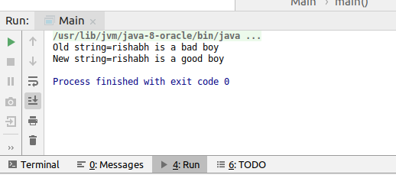
public class Main
{
public static void main(String[] args) {
StringBuffer s=new StringBuffer("rishabh is a bad boy");
System.out.println("Old string="+s);
String substring="bad";
String replace="good";
int i=s.indexOf(substring);
if(i>-1)
{
s.replace(i,i+substring.length(),replace);
System.out.println("New string="+s);
}
}
}

Another Way:
String name = "Rishabh is a bad boy";
String substring = "bad";
String replaceword = "good";
if (name.contains(substring)) {
String s = name.replace(substring, replaceword);
System.out.println(s);
} else {
System.out.println("no");
}
}

Question 2:Write a program to find the number of occurrences of the duplicate words in a string and print them ?

Solution2:
package Mypackage;
import com.sun.org.apache.bcel.internal.generic.IFEQ;
import java.sql.SQLOutput;
import java.util.HashMap;
import java.util.Map;
public class First
{
public static void main(String[] args)
{
String string="My name is rishabh & my EmailID is Rishabh.Khatreja03@gmail.com. Rishabh is my name";
Map<String,Integer> map=new HashMap<>();
String word="";
for(int i=0;i<string.length();i++)
{
if(string.charAt(i)==' '|| i==string.length()-1)
{
if(i==string.length()-1)
{
word=word+string.charAt(i);
if(map.containsKey(word))
{
int count=map.get(word);
count++;
map.put(word,count);
word=" ";
}
else
{
map.put(word,1);
word=" ";
}
}
else
{
if(map.containsKey(word))
{
int count=map.get(word);
count++;
map.put(word,count);
word=" ";
}
else
{
map.put(word,1);
word=" ";
}
}
}
else
{
word=word+string.charAt(i);
}
}
System.out.println(map);
for (String key:map.keySet())
{
if(map.get(key)>1)
{
System.out.println("duplicate words are="+key);
}
}
}
}

Question3:Write a program to find the number of occurrences of a character in a string without using loop?

Solution3:

public class Occurence_Character
{
public static void main(String[] args) {
String string="my name is rishabh";
int a=string.replace("a","").length();
System.out.println(string.length()-a);
}
}
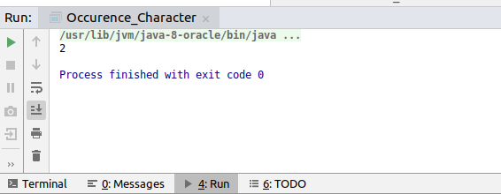

Question4:Calculate the number & Percentage Of Lowercase Letters,Uppercase Letters, Digits And Other Special Characters In A String.

Solution4:

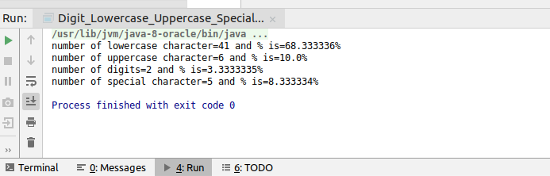

public class Digit_Lowercase_Uppercase_SpecialCharacter
{
public static void main(String[] args) {
String string="My name is rishabh & my EmailID:Rishabh.Khatreja03@gmail.com";
int lowerCase=0,upperCase=0,digits=0,SpecialCharacter=0;
for(int i=0;i<string.length();i++)
{
if(string.charAt(i)>='a' && string.charAt(i)<='z')
{
lowerCase=lowerCase+1;
}
else if(string.charAt(i)>='A' && string.charAt(i)<='Z')
{
upperCase=upperCase+1;
}
else if(Character.isDigit(string.charAt(i)))
{
digits=digits+1;
}
else if(!(string.charAt(i)==' '))
{
SpecialCharacter=SpecialCharacter+1;
}
}
System.out.println("number of lowercase character="+lowerCase+" and % is="+((float)lowerCase/string.length())*100+"%");
System.out.println("number of uppercase character="+upperCase+" and % is="+((float)upperCase/string.length())*100+"%");
System.out.println("number of digits="+digits+" and % is="+((float)digits/string.length())*100+"%");
System.out.println("number of special character="+SpecialCharacter+" and % is="+((float)SpecialCharacter/string.length())*100+"%");
}
}

Question5:Find common elements between two arrays.

Solution5:

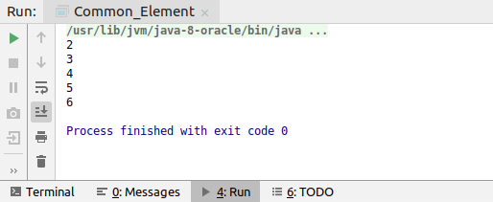
public class Common_Element
{
public static void main(String[] args) {
int[] arr1={2,3,4,5,6};
int[] arr2={1,2,3,4,5,6,8,9};
for(int i=0;i<arr1.length;i++)
{
for(int j=0;j<arr2.length;j++)
{
if(arr1[i]==arr2[j])
{
System.out.println(arr1[i]);
}
}
}
}
}
2nd method:

import java.util.*;
public class Common_Element
{
public static void main(String[] args) {
int[] arr1={2,3,4,5,6,9,12,45};
int[] arr2={5,6,9,12};
Map<Integer,Integer> common=new HashMap<>();
for(int i=0;i<arr1.length;i++)
{
common.put(arr1[i],1);
}
for(int i=0;i<arr2.length;i++)
{
if(common.containsKey(arr2[i]))
{
int k=common.get(arr2[i]);
k++;
common.put(arr2[i],k);
}
else
{
common.put(arr2[i],1);
}
}
for (int key:common.keySet())
{
if(common.get(key)>1)
{
System.out.println(key);
}
}
}
}

Question6:There is an array with every element repeated twice except one. Find that element

Solution6:

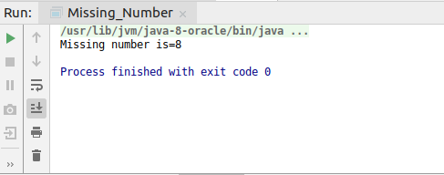

public class Missing_Number {
public static void main(String[] args)
{
int[] arr1={1,2,3,4,5,6,7,8,1,2,3,4,5,6,7};
int m=0,sum=0;
for(int i=0;i<arr1.length;i++)
{
if(m<arr1[i])
{
m=arr1[i];
}
}
sum=(m*(m+1)/2)*2;
for(int i=0;i<arr1.length;i++)
{
sum=sum-arr1[i];
}
System.out.println("Missing number is="+sum);
}
}
------------------------------------------------------------------------------------------------------------
public class Missing_Number {
public static void main(String[] args)
{
int[] arr1={20,31,41,56,20,41,31,58,11,58};
for(int i=0;i<arr1.length-1;i++)
{
for(int j=i+1;j<arr1.length;j++)
{
if(arr1[i]>arr1[j])
{
int temp;
temp=arr1[i];
arr1[i]=arr1[j];
arr1[j]=temp;
}
}
}
for(int i=0;i<arr1.length;i++)
{
System.out.println(arr1[i]);
}
for (int i=0;i<arr1.length;i=i+2)
{
if(i==arr1.length-1)
{
System.out.println("missing number is="+arr1[i]);
break;
}
if(arr1[i]==arr1[i+1])
{
continue;
}
else
{
System.out.println("missing number is="+arr1[i]);
break;
}
}
}
}

import java.util.*;
public class Missing_Number {
public static void main(String[] args)
{
int[] arr1={2,3,5,1,7,8,1,2,3,5,8};
Map<Integer,Integer> mapOfElement=new HashMap<>();
for(int i=0;i<arr1.length;i++)
{
if(mapOfElement.containsKey(arr1[i]))
{
int keyValue=mapOfElement.get(arr1[i]);
keyValue++;
mapOfElement.put(arr1[i],keyValue);
}
else
{
mapOfElement.put(arr1[i],1);
}
}
for (int key:mapOfElement.keySet())
{
if(mapOfElement.get(key)==1)
{
System.out.println(key);
}
}
}
}

Question7:Write a program to print your Firstname,LastName & age using static block,static method & static variable respectively.

Solution7:
public class Static_Block_method {
static String firstName,lastName;
static int age;
static
{
System.out.println("From static block------------");
System.out.println("firstName="+firstName);
System.out.println("lastName="+lastName);
System.out.println("Age="+age);
}
public static void display()
{
System.out.println("From static method-----------------");
System.out.println("firstName="+firstName);
System.out.println("lastName="+lastName);
System.out.println("Age="+age);
}
public Static_Block_method(String firstName, String lastName, int age)
{
Static_Block_method.firstName=firstName;
Static_Block_method.lastName=lastName;
Static_Block_method.age=age;
}
public static void main(String[] args)
{
Static_Block_method obj=new Static_Block_method("Rishabh","khatreja",23);
display();
}
}

public class Static_Block_method {
static String firstName,lastName="khatreja";
static int age=23;
static
{
firstName="rishabh";
System.out.println("From static block------------");
System.out.println("firstName="+firstName);
System.out.println("lastName="+lastName);
System.out.println("Age="+age);
}
public static void display()
{
System.out.println("From static method-----------------");
System.out.println("firstName="+firstName);
System.out.println("lastName="+lastName);
System.out.println("Age="+age);
}
public Static_Block_method(String firstName, String lastName, int age)
{
Static_Block_method.firstName=firstName;
Static_Block_method.lastName=lastName;
Static_Block_method.age=age;
}
public static void main(String[] args)
{
//Static_Block_method obj=new Static_Block_method("Rishabh","khatreja",23);
display();
}
}

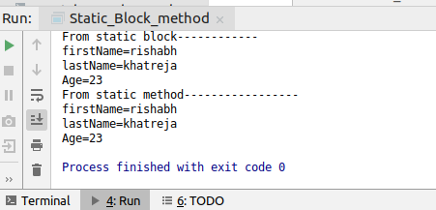

Question8:Write a program to reverse a string and remove character from index 4 to index 9 from the reversed string using String Buffer

Solution8:
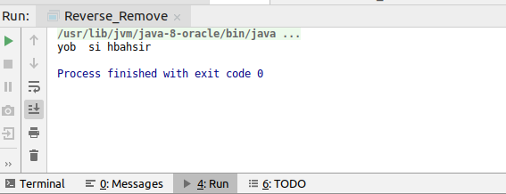
public class Reverse_Remove
{
public static void main(String[] args) {
StringBuffer s=new StringBuffer("rishabh is a bad boy");
s.reverse();
s.delete(4,9);
System.out.println(s);
}
}

Question 9:Write a program to display values of enums using a constructor & getPrice() method (Example display house & their prices)

Solution 9:

Question10:Write a single program for following operation using overloading
A) Adding 2 integer number
B) Adding 2 double
C) multiplying 2 float
D) multiplying 2 int
E) concate 2 string
F) Concate 3 String

Solution10:

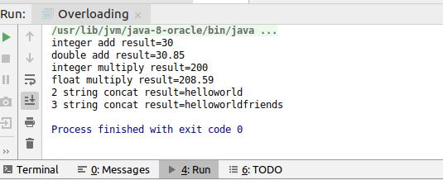
class Overload
{
public int add(int number1, int number2)
{
return number1+number2;
}
public double add(double number1, double number2)
{
return number1+number2;
}
public int multiply(int number1, int number2)
{
return number1*number2;
}
public Float multiply(float number1, float number2)
{
return number1*number2;
}
public String concat(String s1, String s2)
{
return s1+s2;
}
public String concat(String s1,String s2,String s3)
{
return s1+s2+s3;
}
}
public class Overloading
{
public static void main(String[] args)
{
Overload obj=new Overload();
int addIntResult=obj.add(10,20);
double addDoubleResult=obj.add(10.40,20.45);
int mulIntResult=obj.multiply(10,20);
float mulFloatResult=obj.multiply(10.20f,20.45f);
String concat2Strings=obj.concat("hello", "world");
String concat3Strings=obj.concat("hello", "world","friends");
System.out.println("integer add result="+addIntResult);
System.out.println("double add result="+addDoubleResult);
System.out.println("integer multiply result="+mulIntResult);
System.out.println("float multiply result="+mulFloatResult);
System.out.println("2 string concat result="+concat2Strings);
System.out.println("3 string concat result="+concat3Strings);
}
}

Question 11:Create 3 sub class of bank SBI,BOI,ICICI all 4 should have method called getDetails which provide there specific details like rateofinterest etc,print details of every banks

Solution11:

